1. Write a Python program to get the Python version you are using.

import sys

print("Python version")

print (sys.version)

print("Version info.")

print (sys.version_info)

help('modules')

List all modules in Python

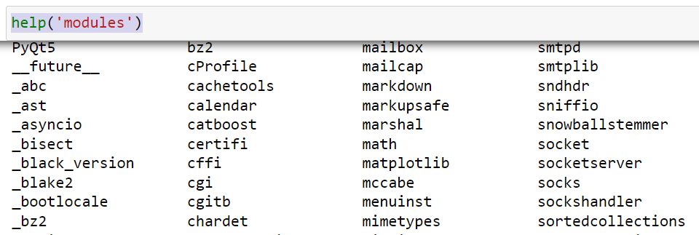

2. Write a Python program to display the current date and time.  
Sample Output :  
Current date and time :  
2014-07-05 14:34:14

**Options 1**

import datetime

x = datetime.datetime.now()

print(x)

**Options 2**

import datetime

now = datetime.datetime.now()

print ("Current date and time : ")

print (now.strftime("%Y-%m-%d %H:%M:%S"))

**strftime()** is a Python date method you can use **to convert dates to strings**. It doesn't just convert to strings but also allows you to format your dates in a readable way

**Available Date Formats**

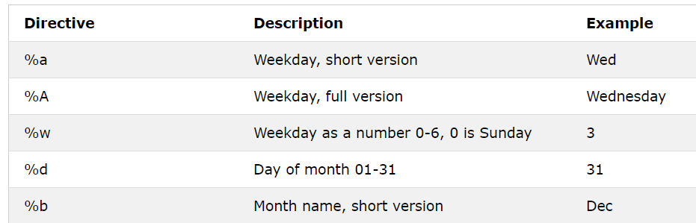

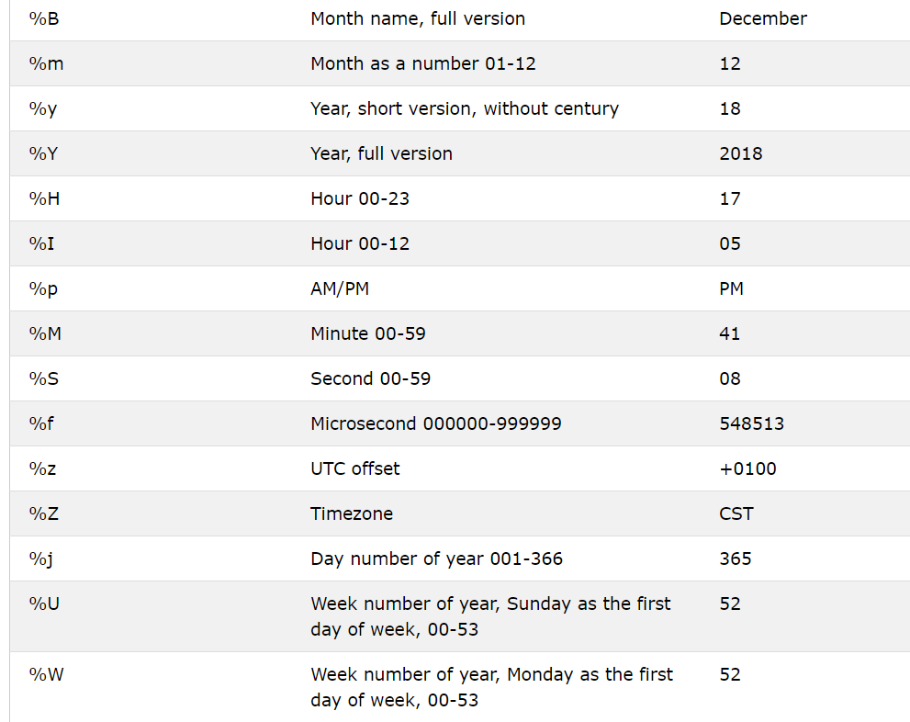

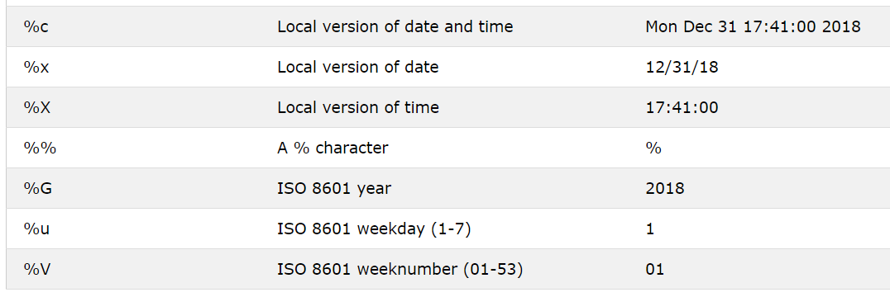

3. Write a Python program which accepts the radius of a circle from the user and compute the area.

Sample Output :  
r = 1.1  
Area = 3.8013271108436504

from math import pi

r = float(input ("Input the radius of the circle : "))

print ("The area of the circle with radius " + str(r) + " is: " + str(pi * r**2))

4.Write a Python program which accepts the user's first and last name and print them in reverse order with a space between them

fname = input("Input your First Name : ")

lname = input("Input your Last Name : ")

print ("Hello " + lname + " " + fname)

5.Write a Python program which accepts a sequence of comma-separated numbers from user and generate a list and a tuple with those numbers

Sample data : 3, 5, 7, 23  
Output :  
List : ['3', ' 5', ' 7', ' 23']  
Tuple : ('3', ' 5', ' 7', ' 23')  
The split() method splits a string into a list.

You can specify the separator; default separator is any whitespace.

Syntax

string.split(separator, maxsplit)

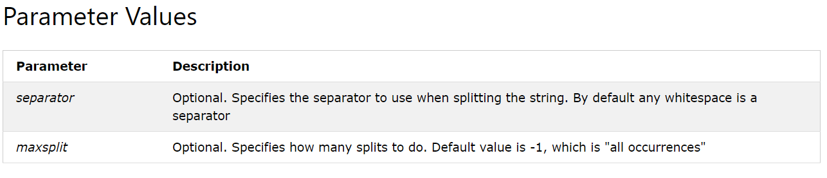

values = input("Input some comma separated numbers : ")

list1 = values.split(",")

tuple1 = tuple(list1)

print('List : ',list1)

print ('Tuple : ',tuple1)

*Other examples -1*

txt = "hello, my name is Peter, I am from UK"  
  
x = txt.split(", ")  
  
print(x)

*Other examples -2*

txt = "apple#banana#cherry#orange"  
  
x = txt.split("#")  
  
print(x)

*Other examples -3*

txt = "apple#banana#cherry#orange"  
  
# setting the maxsplit parameter to 1, will return a list with 2 elements!  
x = txt.split("#", 1)  
  
print(x)

6.Write a Python program to accept a filename from the user and print the extension of that.

Sample filename : abc.java  
Output : java

The repr() function returns a printable representational string of the given object.

filename = input("Input the Filename: ")

f_extns = filename.split(".")

print ("The extension of the file is : " + repr(f_extns[-1]))

str() displays today’s date in a way that the user can understand the date and time.

repr() prints “official” representation of a date-time object (means using the “official” string representation we can reconstruct the object).

The __repr__ **method returns the string representation of an object.** Typically, the __repr__() returns a string that can be executed and yield the same value as the object. In other words, if you pass the returned string of the object_name.

**built-in str() and repr() functions both produce a textual representation of an object**. The difference between str() and repr() is: The str() function returns a user-friendly description of an object. The repr() method returns a developer-friendly string representation of an object.

Example

import datetime

today = datetime.datetime.now()

print (today)

print (str(today))

#prints the official format of date-time object

print (repr(today))

7.Write a Python program to display the first and last colors from the following list.    
color_list = ["Red","Green","White" ,"Black"]

color_list = ["Red","Green","White" ,"Black"]

print( "%s %s"%(color_list[0],color_list[-1]))

8.Write a Python program that accepts an integer (n) and computes the value of n+nn+nnn.   
Sample value of n is 5Expected Result : 615

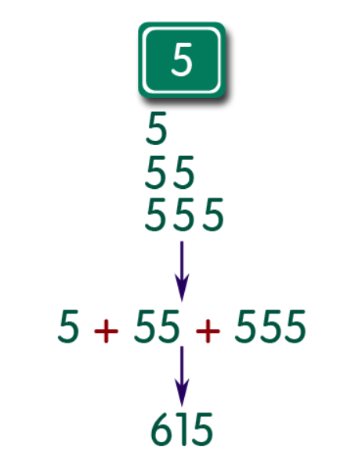

a = int(input("Input an integer : "))

n1 = int( "%s" % a )

n2 = int( "%s%s" % (a,a) )

n3 = int( "%s%s%s" % (a,a,a) )

print (n1+n2+n3)

9.Write a Python program to get the volume of a sphere with radius 6.

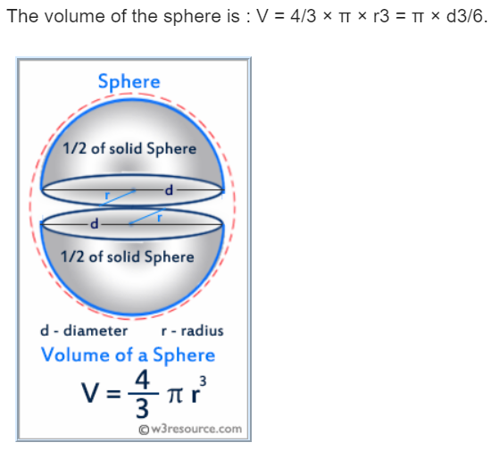

pi = 3.1415926535897931

r= 6.0

V= 4.0/3.0*pi* r**3

print('The volume of the sphere is: ',V)

**10.**Write a Python program to convert seconds to day, hour, minutes and seconds.

time = float(input("Input time in seconds: "))

day = time // (24 * 3600)

time = time % (24 * 3600)

hour = time // 3600

time %= 3600

minutes = time // 60

time %= 60

seconds = time

print("d:h:m:s-> %d days :%d hours:%d minutes:%d seconds" % (day, hour, minutes, seconds))